Sudo

What is sudo:
Sudo (super user do)sudo runs a command as root, whereas su makes you root user.

sudo :- Allows a permitted user to execute a command as a super user as specified in the SUDOER's file .

SUDO runs a single command with root privilege. SUDO it doesn’t switch to the root user or require a separate root user password.

Sudo configuration file:
#vi /etc/sudoers
(or)
#visudo

Syntax for individual user:
===============================
User HOST=RunAs NOPASSWD:COMMAND
mahesh ALL=(ALL) ALL
balaji ALL=(ALL) ALL

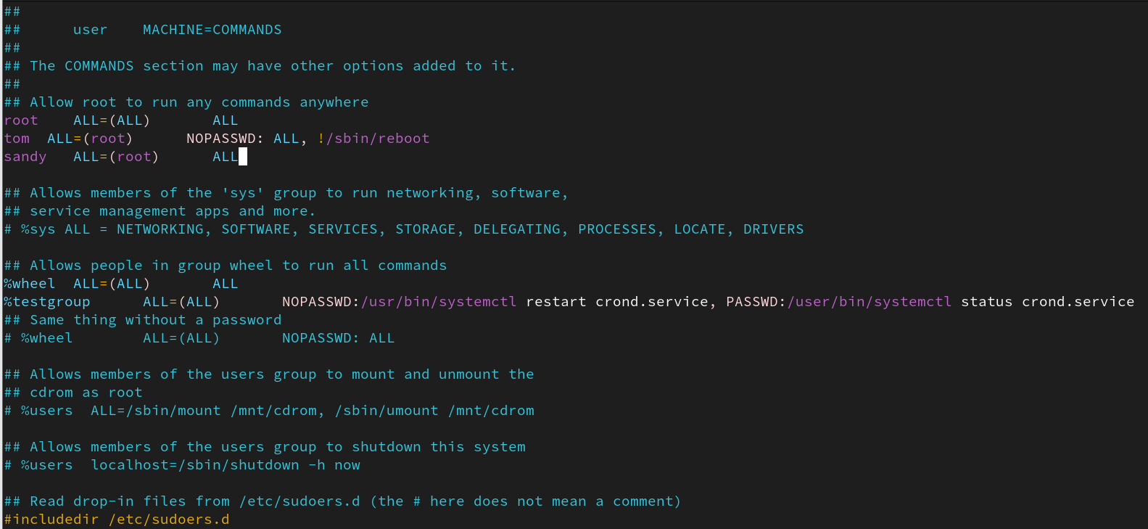

User HOST=RunAs(user) NOPASSWD:COMMAND
mahesh ALL=(balaji) ALL

Syntax for individual group:
==============================
%group HOST=RunAs NOPASSWD:COMMAND

%admin ALL=ALL ALL

In %wheel group => sudo access is set as default.

balaji ALL=(ALL) NOPASSWD:/usr/bin/systemctl restart crond.service, PASSWD:/usr/bin/systemctl status crond.service

mahesh ALL=(ALL) ALL
daniel ALL=(ALL) !/bin/su !/bin/bash !/reboot
niresh ALL=(daniel) ALL

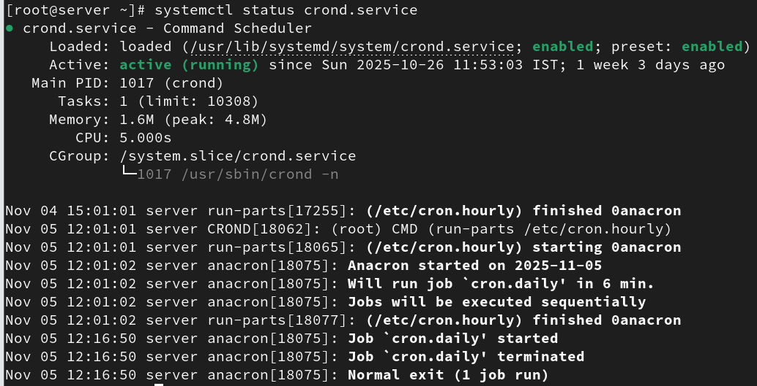

List User Privileges:
#sudo -l (or) #sudo –list

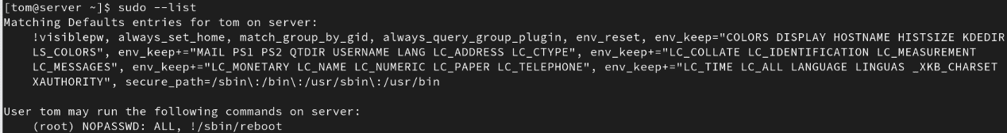

#sudo -U user_name -l

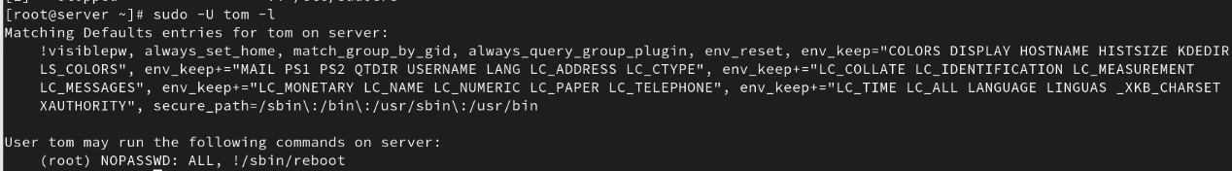

Change Your Interactive Shell
#sudo -I

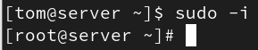

Aliases in sudoers file
=============================
User_Alias
Host_Alias
Cmnd_Alias

Host_Alias MAILSERVERS = smtp, smtp2
Cmnd_Alias DELEGATING = /usr/sbin/visudo, /bin/chown, /bin/chmod, /bin/chgrp
User_Alias ADMINS = mahesh, niresh, daniel

User_Alias ADMINS = balaji, muthu, vicky
Cmnd_Alias ALLOW_CMD = /usr/sbin/fdisk ,/usr/sbin/useradd
Cmnd_Alias DENY_CMD=!/bin/su,!/usr/sbin/reboot,!/usr/bin/passwd
#Host_Alias MAILSERVERS = smtp, smtp2

ADMINS ALL=(ALL) ALLOW_CMD,DENY_CMD

#daniel ALL=(ADMINS) NOPASSWD: PROCESSES ,DELEGATING
ADMINS ALL=(ALL) NOPASSWD: PROCESSES ,DELEGATING
balaji ALL=(ALL) NOPASSWD: PROCESSES #,DELEGATING

